TRIVENI 1BM19CS411

**BDA LAB** PRACTICE PROGRAM 1

nsertion

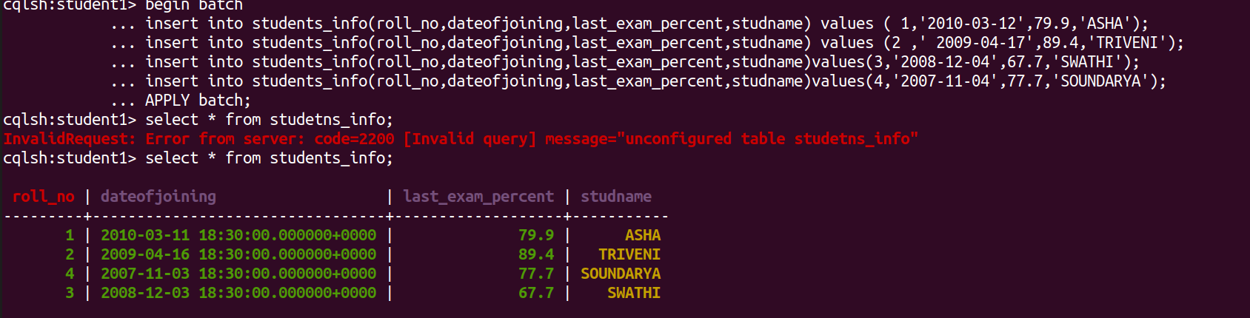

Query 1,2,3,,4

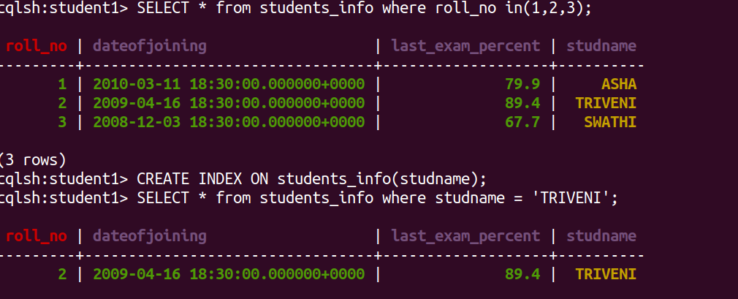

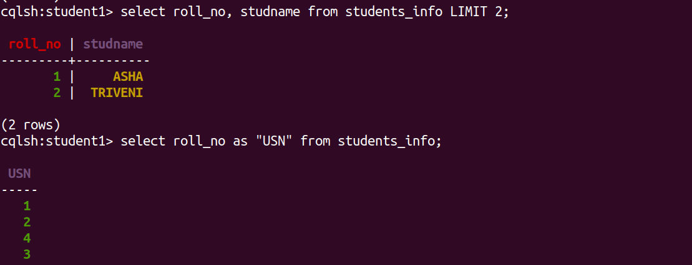

USE OF SET and LIST

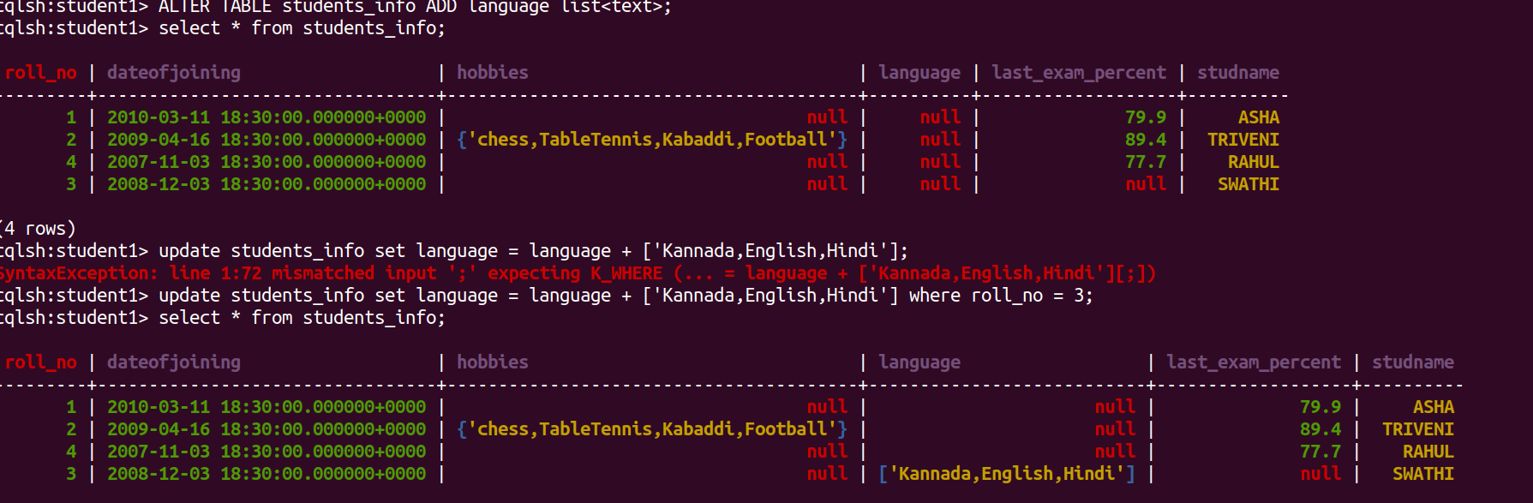

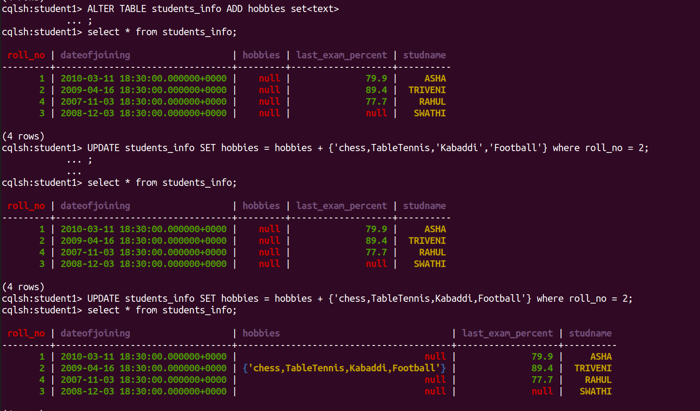

Time To Live

